**# Domain name should be created for exposing services to IBM Intranet**.

**# Request for creation is submitted by Platform team. You can check if it is already created here:**

[**https://cwt01.webmaster.ibm.com/dns/records**](https://cwt01.webmaster.ibm.com/dns/records)

Search key: map-mktsys

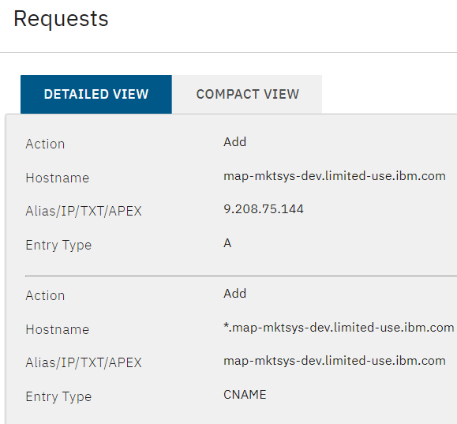

**# Request SSL certificate creation for your desired hostname**

**# Generate CSR file**

[**https://csrgenerator.com/**](https://csrgenerator.com/)

Country **US**

State **NC**

Locality **Durham**

Organization **IBM**

Organizational Unit **CIO**

Common Name **airflow.map-mktsys-dev.limited-use.ibm.com**

Key Size **2048**

**# Filenames**

airflow_map-mktsys-dev_limited-use_ibm_com.csr

airflow_map-mktsys-dev_limited-use_ibm_com_private.key

**# Create profile in IBM Internal Certificate Authority**

[**https://daymvs1.pok.ibm.com/ibmca/welcome.do?id=19222**](https://daymvs1.pok.ibm.com/ibmca/welcome.do?id=19222)

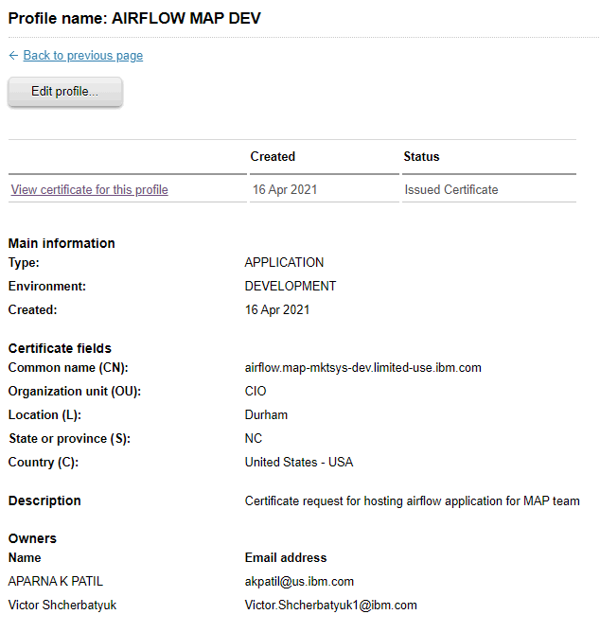

**# Request certificate in IBMCAPKI using earlier generated CSR file**

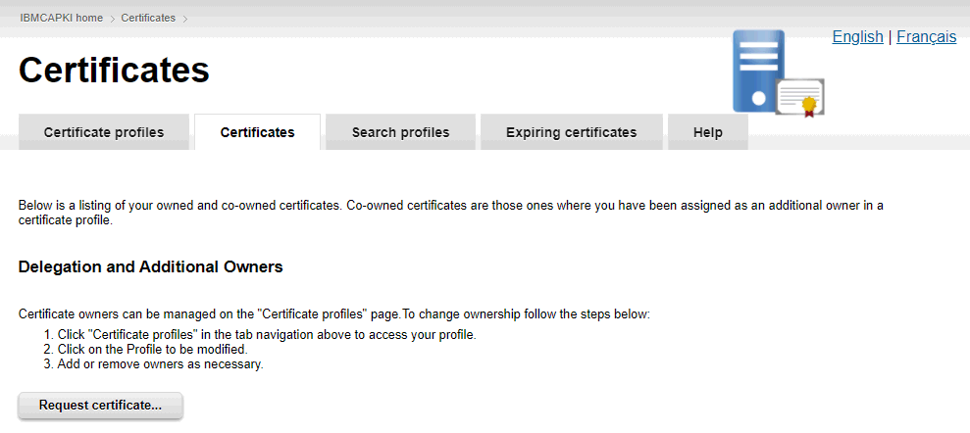

**# Download issued certificate**

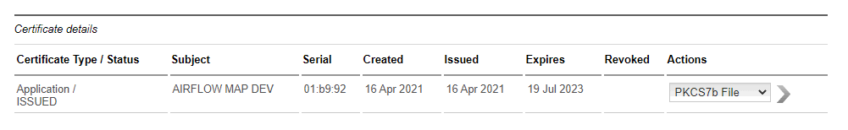

**# Filename**

cert.pem

**# Obtain a copy of IBM intermediate and root certs**

**# Filenames**

caintermediate.pem

caroot.pem

**# Upload certificate to IBM Cloud**

[**https://cloud.ibm.com/resources**](https://cloud.ibm.com/resources)

**# Navigate to: Services -** [**kube-c0hhi59d0s2ho34b3s00**](https://cloud.ibm.com/services/cloudcerts/crn%3Av1%3Abluemix%3Apublic%3Acloudcerts%3Aus-south%3Aa%2Fa2edaeffb1cb4cd3a6aefe5282468938%3Aae8edb9f-492e-457c-becd-5d16f7ab3232%3A%3A) **- Your Certificates - Import**

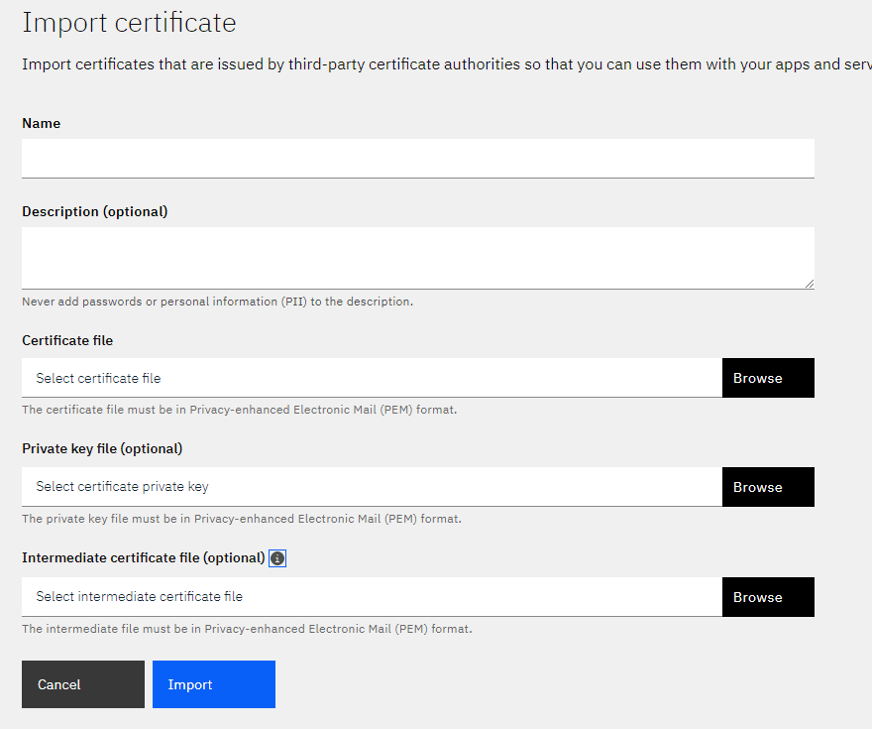

**# As a result you get your certificate imported and it gets CRN**

